AP EXAM 2026 : STUDENT REGISTRATION AND PAYMENT

Test Centre: ADANI INTERNATIONAL SCHOOL, Ahmedabad
Center Address: Adani International School, Opposite Belvedere Golf and Country Club Shantigram, Sarkhej
- Gandhinagar Hwy, near Vaishnodevi Circle, Ahmedabad, Gujarat 382501
AP Coordinator: Ms. Veena Haldankar
AP Coordinator's Email: careercounsellor@adaniinternational.edu.in (The payment transaction details along with name, address & phone number of the examinee to be shared on this email only)
Contact Phone: +917227036311/7969228122 (No messages)
Contact Hours: 9:00 am – 3:00 pm (Monday – Friday)

Registration & Payment Deadline: Second Registration is OPEN NOW!! The deadline to pay and register is 12th March, 2026.

SECOND REGISTRATION WINDOW
Registration Start Date: 12th December 2025 | Registration End Date:12th March,2026 (5:00 pm IST)
Regular testing  (4th - 8th May, 2026 & 11th - 15th May, 2026) | Rs 19000/- INR (per exam)
Late testing (18th - 22nd May, 2026) | Rs 21000/- INR (per exam)

Refund Policy: No refund policy (for no shows or cancellations or name transfers)

REGISTRATION AND PAYMENT INSTRUCTIONS

Complete ALL STEPS BELOW (register online and pay test center) by 12th March,2026 to reserve your seat. The Test Center will provide an AP Admission Ticket by 24th March, 2026 as confirmation that your seat is reserved.
- Registration will not be confirmed if you do not complete the following steps:
- Create account with My AP on College Board (as per instructions given below)
- Make online payment within three days of registration on My AP as per account details given on the Adani International School website.
- STUDENTS WILL HAVE TO BRING THEIR OWN LAPTOP FOR TESTING https://bluebook.collegeboard.org/students
- Students in any of the categories below are eligible to take AP Exams at the secondary school where they are enrolled or at other AP-authorized schools or test centres:
  - Students actively enrolled in secondary school.
  - Secondary school-level students who are homeschooled, participate in independent study, or attend a virtual school.
  - Actively enrolled students who may be prepared to take an AP Exam prior to the ninth grade.
  - Recent secondary school graduates who need a specific AP Exam for university admission.

Important Note:
- IF YOU REGISTER ONLINE WITH THE COLLEGE BOARD BUT DO NOT PAY THE TEST CENTER, YOU WILL NOT BE ABLE TO TAKE THE TEST.
- IF YOU PAY TO THE TEST CENTRE BUT DO NOT COMPLETE ONLINE REGISTRATION ON COLLEGEBOARD, YOU WILL NOT BE ABLE TO TAKE THE TEST.

TO START: Use a phone, tablet, or computer to complete registration online with the College Board– Follow instructions here:
https://apcentral.collegeboard.org/media/pdf/joining-your-ap-class-section-students.pdf

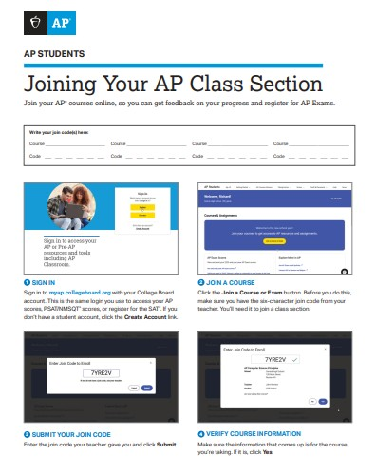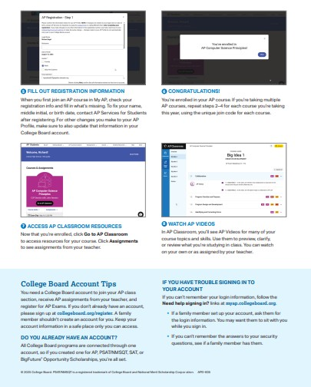

Submit payment to the test center within three (3) business days of completing your online registration, or sooner if required. Email your payment details to the test center coordinator to ensure your payment is properly matched with your registration.

Please refer to the next page for your center’s join codes to complete online registration. (OLD JOIN CODES have expired.)

NEW JOIN CODES (please use this only)
Course Name | Active Join Code
AP Art History | 9N6224
AP Art History Late | VL6M3G
AP Biology | M4JJ44
AP Biology Late | LDQLG3
AP Calculus AB | Q7E7RE
AP Calculus AB Late | 3R7Y9J
AP Calculus BC | V7YXAM
AP Calculus BC Late | J7M2WV
AP Chemistry | P3NV9J
AP Chemistry Late | 4PWEEM
AP Computer Science A | 377Y6Z
AP Computer Science A Late | G67DNE
AP Computer Science Principal | WR7P3R
AP Comp Science Principles Late | GDNZVD
AP Eng Lang and Composition | R9YJVQ
AP Eng and Composition Late | MJ69M3
AP Eng Lit and Composition | 6927M6
AP Eng Lit and Composition Late | LAYJEN
AP Environmental Science | 7ZW6E7
AP Env Science Late | RYV3Y6
AP European History | NJVX3Y
AP Euro History Late | RM9A2V
AP French Language Culture | AJ4NN3
AP French Language Culture Late | 3G2XR4
AP German Language Culture | 7D9A9R
AP German Language Culture Late | N27VZ6
AP Human Geography | 44RXDQ
AP Human Geography Late | 9YZ97V
AP Italian Language Culture | 9EJLDJ
AP Italian Language Culture Late | L36LDA
AP Japanese Language Culture | EWDGQZ
AP Japan Language Culture Late | A6EZ4M
AP Latin | NR9VR2
AP Latin Late | 27ZM69
AP Macroeconomics | D9M6PM
AP Macroeconomics Late | 4R7XN3
AP Microeconomics | 3EAZ29
AP Microeconomics Late | GRGZ6A
AP Physics 1 | NJY2XN
AP Physics 1 Late | PXDLDG
AP Physics 2 | 4P4NXQ
AP Physics 2 Late | QQQDGV
AP Physics C Electricity and Magnetism | WA2GVR
AP Physics C Electricity and Magnetism Late | QJ9GJN
AP Physics C Mechanics | QN7N3D
AP Physics C Mechanics Late | X9MPLN
AP Precalculus | QAYMRY
AP Precalculus Late | WGQD3J
AP Psychology | JNAMVP
AP Psychology Late | A46PRG
AP Statistics | L6EYPG
AP Statistics Late | MVARAE
AP US Government and Politics | Y6NPN3
AP US Government Politics Late | 7DXLEL
AP US History | 7EN3AQ
AP US History Late | QPMXXP
AP World History Modern | M6D3NQ
AP World History Modern Late | XMLMWQ

RECEIVE ADMISSION TICKET FROM TEST CENTER
The test center will provide an Admission ticket to you after they have ordered your exams. Tickets will be provided no later than 24th March 2026 This ticket is a confirmation that your seat has been reserved. You will need this ticket on exam day, along with an original, valid passport or Aadhar Card, or you will not be able to test.

